**P250/1**

**Geography**

**PHYSICAL GEOGRAPHY**

**Paper 1**

**Jul. /Aug. 2019**

**3 Hours**



**JOINT MOCK EXAMINATIONS, 2019**

Uganda Advanced Certificate of Education

**GEOGRAPHY**

Paper 1

**PHYSICAL GEOGRAPHY**

3 hours

**INSTRUCTIONS TO CANDIDATES:**

* Answer **four** questions in all: Section A is compulsory. At least one question should be answered from section B and one question from section C.
* Credit will be given for the use of relevant sketch maps, diagrams and specific examples studied in the field.
* Any additional question(s) answered will **not** be marked.

**Turn Over**

**SECTION A:**

**COMPULSORY MAPWORK AND PHOTOGRAPHY INTERPRETATION**

Choose **two** questions from this section.

1. **COMPULSORY MAP WORK QUESTION:**

Study the **1:50,000** (UGANDA) MASINDI map extract and answer the questions that follow.

1. (i) State the grid reference of the road junction at Bujenje. **(01 mark)**

(ii) Name the physical feature found at grid reference 545915. **(01 mark)**

1. (i) Measure the distance of the all-weather loose surface road from the road junction at

Masindi grid reference 570872 Atura in the North East. **(01 mark)**

(ii) Calculate the amplitude of the area covered by the map of Masindi**. (02 marks)**

1. Given the new scale of the map of Masindi is 1:125,000.
2. Calculate the reduction factor. **(02 marks)**
3. Use the reduction factor calculated in c(i) above and draw a reduced sketch map of the area covered by the map and on it mark and name

* Any two physical regions
* Any four land use activities
* Any two drainage features. **(09marks)**

1. Describe the relief of the area covered by the map.
2. Describe the relationship between
3. relief and land use
4. drainage and vegetation
5. **COMPULSORY PHOTOGRAPH QUESTIONS**

Study the photograph provided and answer the questions that follow.

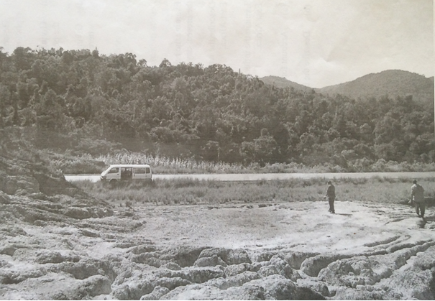

1. Draw a landscape sketch of the area covered by the photograph and on it mark and name:

* any three relief features
* any three land use activities. **(09 marks)**

1. Describe the relationship between relief and land use in the area covered by the photograph. **(06 marks)**
2. Giving evidence from the photograph, explain the problems faced by the people living in the area. **(08 marks)**
3. Giving reasons to support your answer, suggest one area in East Africa where the photograph was taken. **(02 marks)**

**SECTION B**

**GEOMORPHOLOGY**

Attempt **one** question from this section

1. (a) What is continental drift? **(05 marks)**

(b) Examine the relevance of Wegener’s continental drift theory. **(20 marks)**

1. Examine the influence of tectonism on the development of lakes in East Africa.**(25 marks)**
2. Describe the processes leading to the formation of wave erosional landforms. **(25 marks)**

**SECTION C**

**CLIMATE, NATURAL VEGETATION AND SOIL**

Attempt **one** question from this section.

1. (a) Differentiate between weather and climate.  **(05 marks)**

(b) Describe the factors influencing the distribution of rainfall in East Africa. **(20 marks)**

1. (a) Describe the characteristics of Ocean currents.  **(10 marks)**

(b) Describe the effects of Ocean currents on the climate of surrounding areas.

**(15 marks)**

1. To what extent have human activities influenced vegetation zonation in East Africa?

**(25 marks)**

**End**